OUR STATEMENT OF
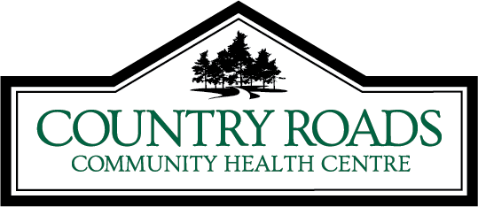
PRIVACY AT COUNTRY ROADS

INFORMATION PRACTICES
This statement explains your privacy rights and the steps our organization takes to protect your Personal Health Information. The law we follow is the Personal Health Information Protection Act, 2004 (PHIPA).

COLLECTION OF YOUR PERSONAL HEALTH INFORMATION
Our organization is a Health Information Custodian (as defined in PHIPA) which means that we store your Personal Health Information in our systems. We collect information directly from you or from the person acting on your behalf (e.g. your Substitute Decision Maker). The information that we collect may include your name, date of birth, Health Card Number, address, health history, records of your visits and the care that you received during those visits, and other relevant information. Occasionally, we may collect information about you from other sources if permitted by law. Such other sources could include other providers working with us to provide you with care or services (e.g. hospitals, clinics, specialists, etc.).

USES AND DISCLOSURES OF YOUR PERSONAL HEALTH INFORMATION

We may use and disclose your Personal Health Information to:
- Treat and care for you alongside the health care providers that are involved in your care (e.g. hospitals, doctors, nurses, nurse practitioners, social workers, etc.);
- Enable you to participate in our programs and services;

- Receive payment for your treatment and care (e.g. from funding agencies, OHIP, WSIB, your private insurer or others);
- Inform funding agencies such as the Ontario’s Ministry of Health and Long-Term Care and Local Health Integration Networks for health system management purposes;
- Guide the planning and administration of our services and operations;
- Conduct quality improvement activities;
- Ensure we comply with legal and regulatory requirements;
- Conduct research;

- Fulfill other purposes permitted or required by law (e.g. infectious disease reporting to Public Health).

YOUR RIGHTS
You may request to access and correct your Personal Health Information, or withdraw your consent for the above uses and disclosures by contacting our privacy officer. Your withdrawal
of consent may be subject to legal exceptions.

SAFEGUARDING YOUR PERSONAL HEALTH INFORMATION
  - We take steps to protect your Personal Health Information from theft, loss and unauthorized access, copying, modification, use, disclosure and disposal.
  - We conduct audits and complete investigations to monitor and manage our privacy compliance and ensure your Personal Health Information is secure.
  - We take steps to ensure that those who perform services for us protect your privacy and only use your information for the purposes you have consented to.

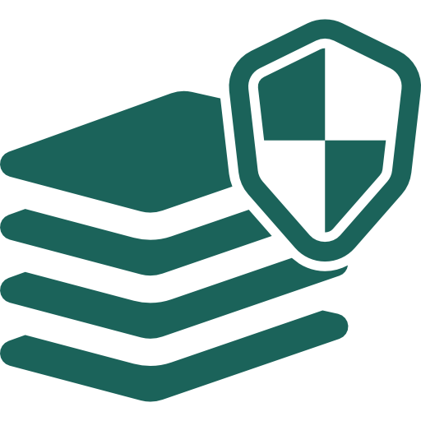

For more information about our privacy practices or to raise a concern, please ask for our privacy officer:
Brandice Hartin 613-272-3443 ext. 240

If you believe your rights have been violated, you can contact the Information and Privacy Commissioner’s Office/Ontario: 2 Bloor Street East, Suite 1400, Toronto, Ontario M4W 1A8
Tel: 416-326-3333 or 1-800-387-0073 Fax: 416-325-9195 Web: www.ipc.on.ca Email: info@ipc.on.ca

Updated-Oct10.indd 1 11/3/2017 11:46:08 AM

